Plan View

186 m

0 m

320 m

FBP X

FBP Y

FBP Z

FCS X

FCS Y

FCS Z

Fire line

Road

320 m

160 m

300 m

250 m

150 m

100 m

50 m

Devices

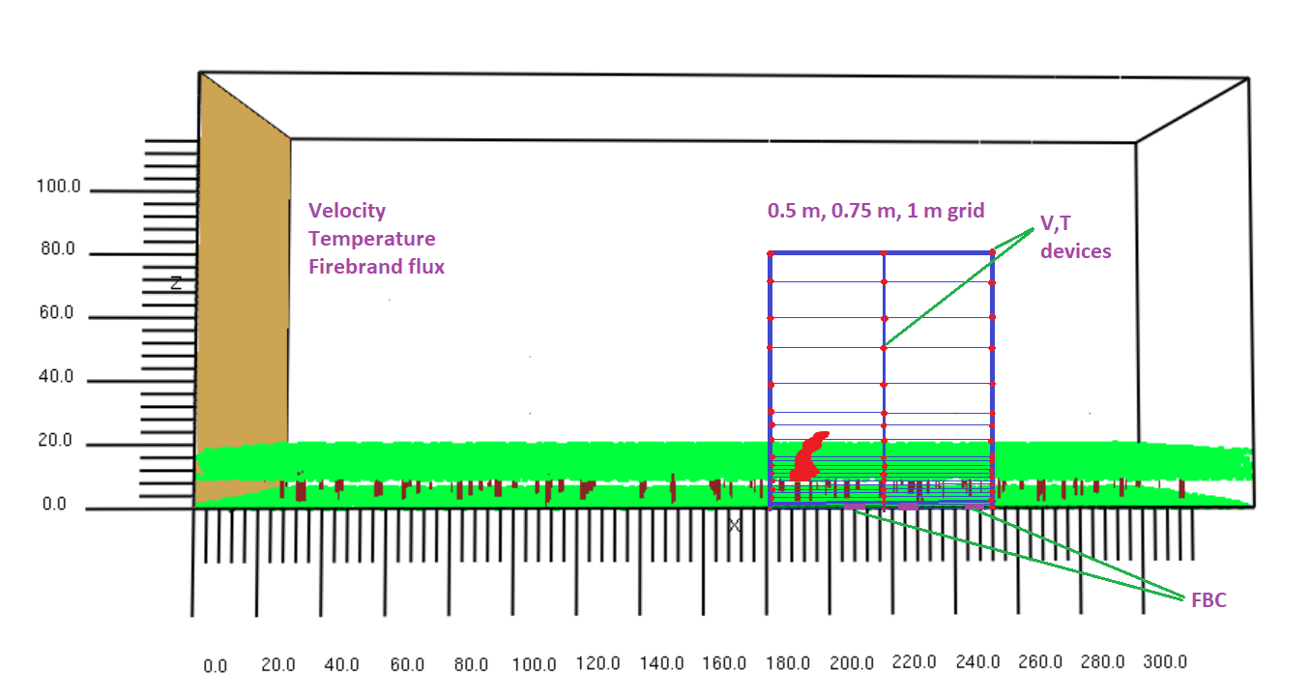

1. Graphical comparison of time-averaged temperature data

|  |
| --- |
|  |

**\*\*MATLAB plotting will be done for different locations.**

|  |
| --- |
|  |
|  |

**Fireline is at x= 186 m

1. Graphical comparison of time series temperature data

|  |
| --- |
| X= 182 m |
| X= 217 m |
| X= 252 m |

1. GCI based on time-series temperature data

|  |  |  |  |  |  |  |
| --- | --- | --- | --- | --- | --- | --- |
|  | GCI (0.75/0. 50) | | | GCI (1.00/0.75) | | |
| Height (m) | x=182 m | x=217 m | x=252 m | x=182 m | x=217 m | x=252 m |
| 0 | 53.43 | 61.3 | 47.9 | 20.9 | 23.4 | 28.8 |
| 5 | 33.24 | 52.2 | 42.9 | 5.4 | 34.6 | 15.7 |
| 10 | 36.57 | 106.4 | 46.1 | 11.7 | 163.4 | 16.8 |
| 15 | 62.16 | 104.2 | 48.6 | 22.2 | 182.3 | 62.1 |
| 20 | 56.00 | 163.9 | 52.9 | 17.0 | 271.0 | 60.1 |
| 30 | 38.04 | 154.2 | 89.8 | 5.5 | 670.3 | 80.5 |
| 40 | 24.86 | 250.5 | 121.5 | 3.1 | 647.8 | 102.9 |
| 50 | 15.80 | 77.6 | 129.0 | 1.3 | 436.2 | 177.8 |
| 60 | 15.48 | 23.2 | 167.2 | 1.7 | 61.3 | 409.6 |
| 70 | 19.76 | 17.2 | 89.1 | 2.0 | 1.3 | 353.8 |
| 80 | 12.70 | 13.8 | 69.7 | 0.9 | 0.8 | 361.6 |

**Fire line height is 9 m above the ground

|  |
| --- |
|  |

1. GCI based on time-averaged temperature data

|  |  |  |  |  |  |
| --- | --- | --- | --- | --- | --- |
| Єrms | | | **GCI (0.75/1.00)** | | |
| x=182 m | x= 217 m | x=252 m | x=182 m | x= 217 m | x=252 m |
| 0.039417 | 0.243196 | 0.085645 | 15.2 | 93.8 | 33.0 |

|  |  |  |  |  |  |
| --- | --- | --- | --- | --- | --- |
| Єrms | | | **GCI (0.50/0.75)** | | |
| x=182 m | x= 217 m | x=252 m | x=182 m | x= 217 m | x=252 m |
| 0.053975 | 2.316011 | 0.079631 | 13.0 | 555.8 (?) | 19.1 |

**\*\*Need to do MATLAB plotting for different locations.**

Velocity profile at Y=0, after initiating fire

|  |
| --- |
|  |

Firebrand flux

|  |  |  |  |
| --- | --- | --- | --- |
| location | Firebrand flux (pcs/m2.s) | | Difference (%) |
| Grid 750 mm | Grid 1000 mm |
| FCS X | 0.0302 | 0.0395 | 23.5 |
| FCS Y | 0.2732 | 0.5149 | 46.9 |
| FCS Z | 0.9921 | 0.7552 | 23.8 |